2. The 48-bit destination address is 18:a6:f7:78:74:0d. It is not the Ethernet

address of gaia.cs.umass.edu, it is the address of my router.



6. The destination address in the Ethernet frame is 70:8b:cd:2e:13:69, this is the Ethernet address of my computer.



8. at 68 bytes

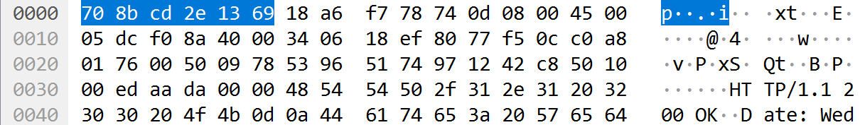

10. source: a8:4e:3f:c2:6b:e2 destination: ff:ff:ff:ff:ff:ff



12.

a) The opcode begins at 20 bytes.

b) 1

c) Yes

d) The target MAC address is set to ff:ff:ff:ff:ff:ff

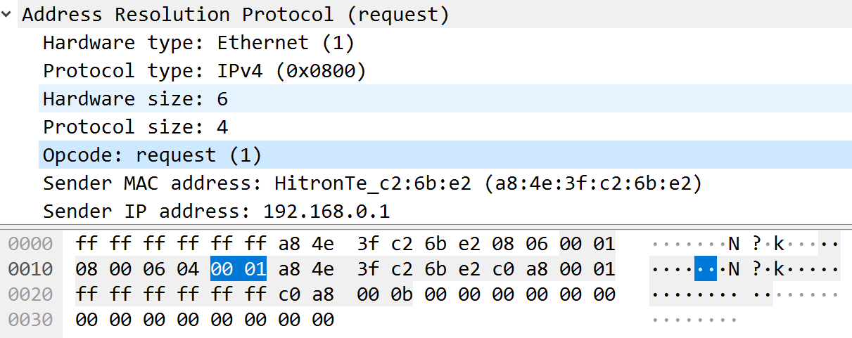

15. The APR only reply to the sender’s computer.